**32146 Assessment Task 1:**

**Data Visualisation**

(Forestville)

Name : Wilcent Wijaya

Student ID : 14378917

Contents

**1.Collecting Dataset:** 3

**2. Supply and demand:** 4

3. Property price: 6

4. Finance: 8

5. Population: 10

6. Ownership: 12

7. Workforce: 14

8. Dwelling: 15

9. Family: 17

Conclusion: 18

# **1.Collecting Dataset:**

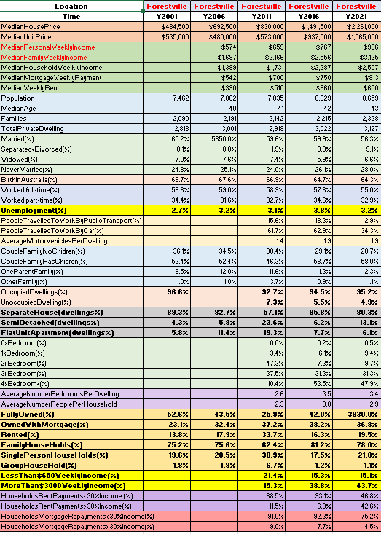

The data above is collected from the Australian Bureau of Statistics’s website. The dataset describe the statistics of Forestville, a suburb in Northern Sydney, located in the state of New South Wales, Australia from five sets of years 2001, 2006, 2011, 2006, and 2021. There are various information that can be analyzed from the collected dataset, such as the dwelling status, family status, population, financial information, and property information. In this report, various factors will be analyzed to produce a logical and analytical recommendations and conclusions.

There will be comparisons between variables in order to assess changes throughout the years in the dataset, this could explain why the data fluctuates in specific ways in order to support a knowledgeable conclusion.

# **2. Supply and demand:**

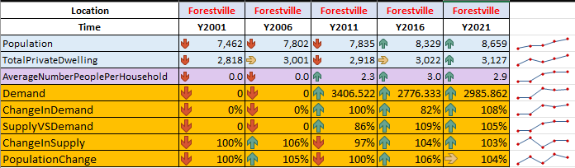

Figure

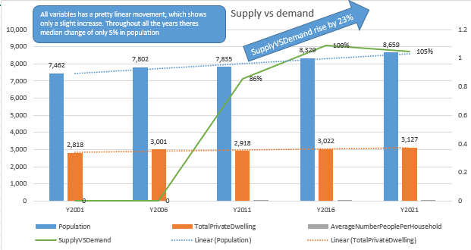

Figure

There are missing data in the dataset from the year 2001 and 2006, therefore the values will be replaced with 0 so that the missing values will not interfere with the movement of the data. The demand is calculated by dividing Population and Average Number People Per Household of the area. The supply in the dataset is the variable TotalPrivateDwelling. The table above suggests from the year 2011 to 2021 there has only been a slight increase overall on the ratio of supply to demand, this could possibly due to the little increase of population throughout the years. Furthermore, the only noticeable change that happen is with the ratio of supply to demand which has experience quite the increase of 23% in the year 2011 to 2016.

**Visualization Technique**

Since there are various variables in the dataset which involves a lot of correlation it is better to use combination chart to visualize the data. In the chart figure 2 above, we can see that there are a total of 4 main factors, which are Population, TotalPrivateDwelling, AverageNumberPeoplePerHousehold, and SupplyVSDemand. The first 3 variables is visualized in columns while the SupplyVSDemand variable is in the form of a line, this is because the goal of the chart is to visualize the correlation of the 3 main variables with the SupplyVSDemand line to show the growth movement in each respective year. Data labels are also added for each variable for more detail accompanied by shapes to mark significant movements inside the chart. Furthermore, trendlines are also included in order to show the overall movements of the chart.

**Summary**

From the year 2001 to the year 2021 there has only been a total population increase of 14% in Forestville, this could be the reason why there's little to no change to almost all the variables. There's a total increase of 10% increase in supply throughout the years followed by a decrease of 14% in demand from the year 2011 to 2021. The decrease of the demand could be the result of the increase in average number of people per household from the year 2011 to 2021 since there's more people in each residential property than people wanting to buy property, this matter could be related to the family and marital status of Forestville.

# 3. Property price:

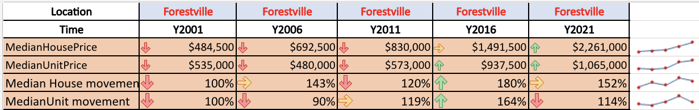

Figure

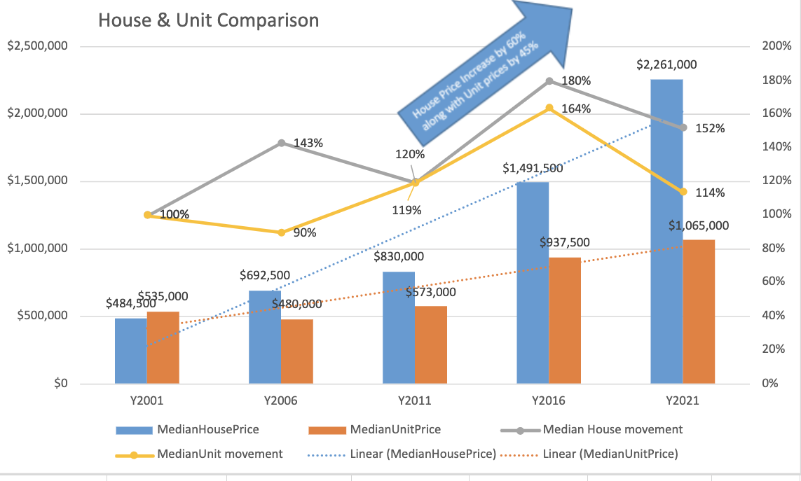

Figure

From the figure 4 above, we can see that the median of house prices along with the median of unit prices has steadily increased throughout the years. However, both variables have a significant gap from each other. It is clear that house prices experience a more significant rise each respective year than the unit prices and its most significant increase can be seen from the year 2011 to 2016 which is 60%, similarly, the median unit price also experienced quite a noticeable increase of 45% from the year 2011 to 2016. Although both have steadily increased their prices overtime, we can see that the unit price experienced a slight decrease from the year 2001 to 2006 unlike the house price which has shot up by 43% in the same period. House prices have increased by a total of 499% from the year 2001 to 2021 while the unit prices have only grown by half the number of house prices which is 199%.

**Visualization Technique**

There are 4 (MedianHousePrice, MedianUnitPrice, MedianHousePriceMovement, MedianUnitPriceMovement) variables in this section, therefore the use of combo chart is optimal since it could visualize correlations between different variables by using different visualizations in one single chart. From the combo chart above we can see that aside from the use of column chart, there are also trend lines added in order to show the overall movement of both house and unit prices overtime. Furthermore, there are 2 variables (MedianHousePriceMovement, MedianUnitPriceMovement) created to show the movement of prices in percentages for each respective period, to show these variables the line chart is added to show the movement of the percentages from both prices throughout the years. Shapes are also used in the combo chart to describe and highlight significant changes that happen in between periods.

**Summary**

Overall, although both unit prices and house prices have steadily increased over time, it is obvious that in the region of Forestville house prices have the majority favor which results in the huge increase of prices throughout the years while unit prices have only increased slightly every period. The house prices has risen up to 500% for the last 20 years similarly unit prices have also risen significantly although not as much as house prices. The most noticeable increase that happen is in the period of 2011 to 2016, not only house prices went up but also unit prices experienced the same increase, both experienced a rise. We can also see that as supplyVsdemand increases the house and unit price will also increase.

# 4. Finance:

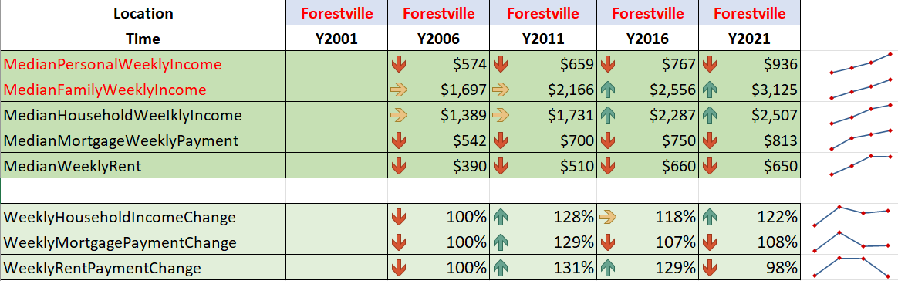

Figure

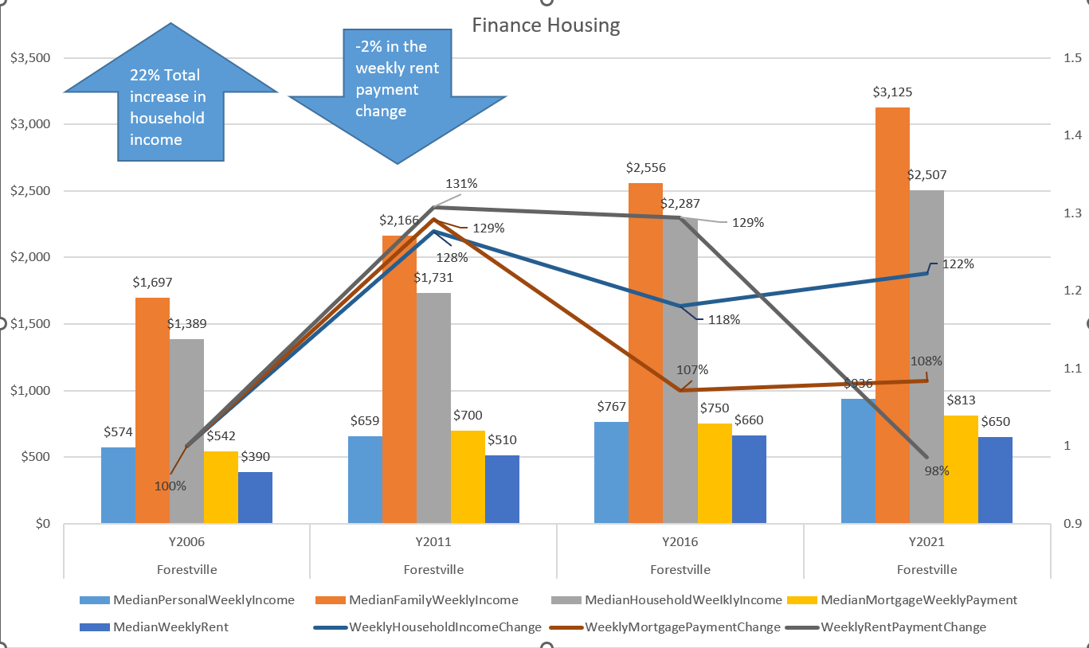

Figure

From the figure 6 above, we can see that overall the income from the population of Forestville has increased throughout the years. From the year 2006 to 2021 the total increase of household income per week is 22%. However, we can see that the rent payments has decreased by 2% from the period of 2006 to 2021 followed by the only slight increase of weekly mortgage payment by only 8%. From the year 2006 to 2011 we can see the high jump of 29% of morgtgage payment followed by 28% increase in household increase alongside 31% increase of rent payments. From the year 2011 to 2016, Mortgage payments decreased by 21% followed by the decrease of household income of 10% alongside the decrease of rent payment by 2%. It is obvious that although overall income has increased, mortgage payments and rent are not hugely affected, however we can correlate this to the property section and supply demand section above. We can assume that as house prices increases the household income will also increase which results to increase in mortgage payments.

**Visualization Technique**

Since there are two factors in this chart which is the income and payments that happen throughout the periods, the utilization of a combo chart is important. Combo chart is ideal when there are quite the number of variables needed to be visualize, correlated, and measured. In this case, the combination of column charts and line stacked line chart is used. The column charts represent the income and payments since the data will be measured by the change represented by the stacked line chart. The stacked line chart illustrates the changes that happen each period regarding the income and payments, furthermore the stacked linechart is also set to rely on the right vertical axis. In addition, shapes are also added to further describe and highlight significant movements along with the repositioning on data labels on the stacked line chart in order to improve readability.

**Summary**

The figure 6 above suggests that there is only slight increases in payments despite the higher rise in income of the population. The increase of house prices leads to higher income which as a result, the increase of mortgage payments, additionally the property owned by mortgage also increased overall which explains the increase of mortgage payments movement change which can be seen in the ownership section. In comparison, the decrease of rent payments is due to the increase of property prices which leads to a higher expenditure as seen in the chart. Furthermore, the decrease of the rent payments change could be explained in correlation of the ownership section which it suggests that rented property has decreased from the year 2011 to 2021 which explains the decrease of rent payments change from the same period.

# 5. Population:

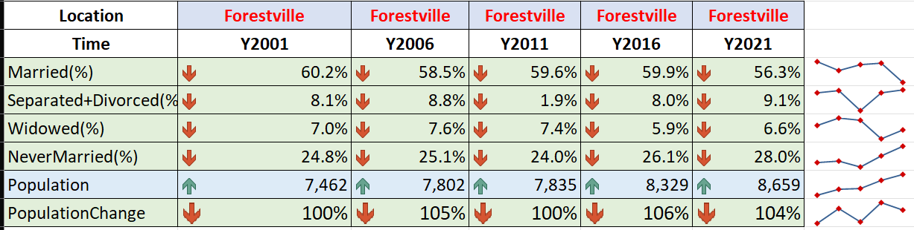

Figure

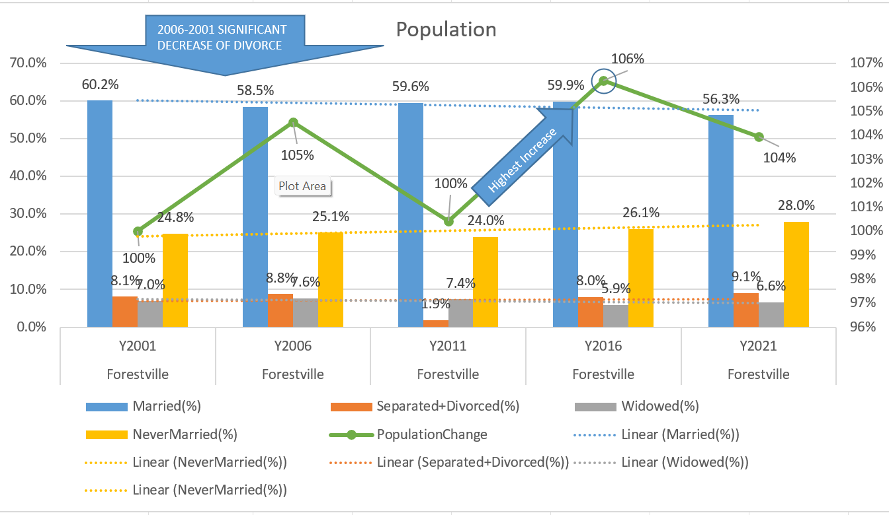

Figure

The figure 8 above suggests that through out the years, the population of Forestville has been steadily increasing slightly. From the year 2001 to 2021 there has been only a total increase of 4%, however we can see that theres a noticeable rise in population change of 6% in the period of 2011 to 2016. We can also see that each period has experienced fluctuations in population growth. On the contrary, the married population in Forestville has decreased slightly by 3.9% from the year 2001 to 2021, however we can see that the married population experienced a slight increase of 1.4% from the year 2006 to 2016 before dropping down by 3.4% from 2016 to 2021. Furthermore, the chart also shows the growth of never married population and divorced population throughout the years. In addition, the overall increase of never married population could be one of the major factors to the population growth since the increase could be from new residents moving to Forestville for the first time or even offsprings from families that have been living in Forestville from the year 2001 to 2021.

**Visualization Technique**

Combo chart is used due to the flexibility it displays by allowing different visualizations in one single chart. There are a total of 5 major variables in the combo chart above figure 8 which are Married, NeverMarried, Divorced, Widowed, and Population. The first four variables are visualized by the column charts, which then separated by their respective time periods. Furthermore, the population is shown by using marked stacked line chart in order to show the change of the population through the time periods, the population line relies on the right vertical axis. Shapes are also added to highlight noticeable changes or movements in the chart along with trendlines to display the overall movement of each variables to improve readability and detail. There are also the addition of data labels and repositioning to improve overall readability and description of each variables in the chart.

**Summary**

Overall, the population of Forestville has been steadily increasing even though by a slight difference. Marriage levels of the population has also decreased throughout the years, this could be correlated to the divorced levels since it has increased by 1% from the year 2001-2021. The data also shows that with the increase of Never married population throughout the time periods, we can assume that as time pass by there are new residents moving into Forestville, furthermore families are also growing as time went by, therefore leads to more growth in population.

# 6. Ownership:

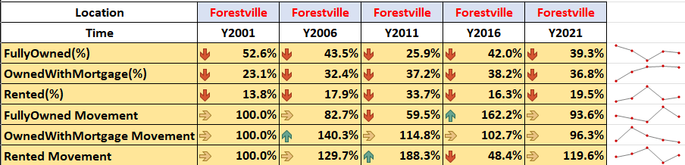

Figure

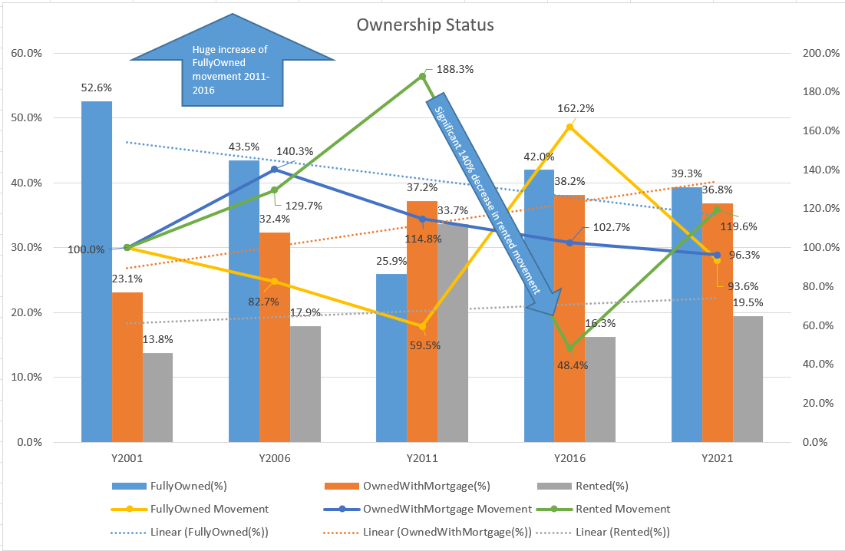

Figure

The figure 10 above suggests that full owned property has slightly decreased over the years by 13.3% while rented property and mortgage property rises by 13.7% and 5.7% respectively. However we can see that there are significant fluctuations on a few time periods, on the year 2006 to 2011 there was a noticeable increase of 15.8% in rented property followed by a huge decrease of 17.4% in the next time period which is almost half of the previous value. Furthermore, fully owned property dropped by 17.6% from the year 2006 to 2011 then increased again by a huge spike of 16.1% back to almost its original value of the previous time period. On the contrary, mortgage property seems to have experienced a linear growth over the years which is shown to be quite stable.

**Visualization Technique**

It is ideal to use combo chart in this section since there are quite a few variables needed to be measured and visualizes. The main variables which are FullyOwned, OwnedWithMortgage, and Rented is visualized by the column charts and designated to each respective time periods. Furthermore, stacked line chart is also used to measure the movement and change on each variable which is set to rely on the vertical axis on the right side of the chart. In addition, shapes were also added to highlight noticeable changes or movements in the chart followed by the additions of data labels which were repositioned to improve readability and description of the chart.

**Summary**

Although the overall fully owned property decreased over the years, mortgaged property increased on a linear movement which suggests stable growth throughout the years. Similarly rented property also experienced a slight increase which correlated with the median weekly rent payment on the house financing section above. The mortgaged property increase also correlates with median mortgage payment from the house financing section above. It is obvious that mortgaged property will grow to surpass fully owned property from the movement of growth on figure 10 and the increasing population.

# 7. Workforce:

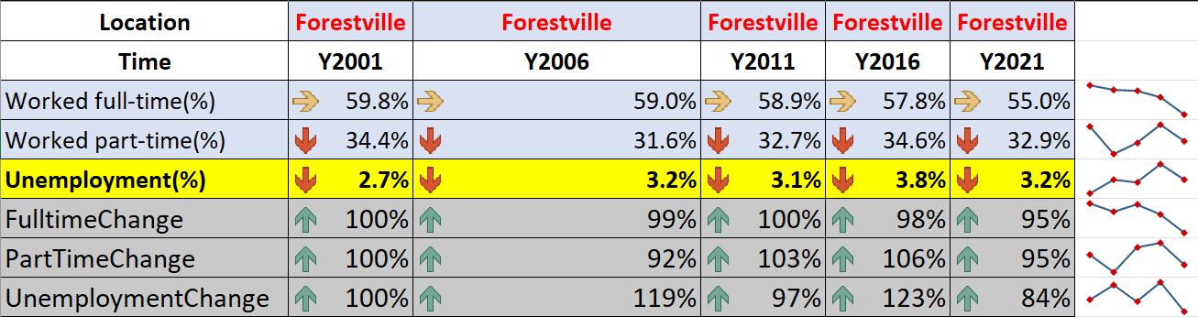

Figure

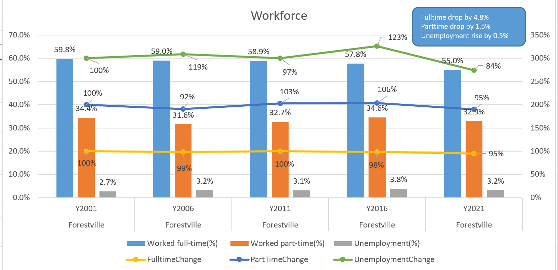

Figure

**Summary**

The figure 12 above suggests that throughout the years both full time and part time workforce has dropped by 4.8% and 1.5% respectively which affected the unemployment rates which risen by 0.5% from 2001 to 2021. Since the population growth of Forestville is not significant, it is expected that the rates of both full time and part time would decrease and as a result the unemployment rate rises which weakens the economy of the region. When an economy of a region weakens, it could result in less demand of property since there will be less expenditure on the region.

**Visualization Technique**

Combo chart is ideal when there are various variables needed to be measured and visualized since it allows different visualizations in a single chart. The column chart is used to represent the 3 main variables which are the full time, part time, and unemployment rates, all three main variables are designated to each respective time period. Furthermore, the stacked line chart is used to measure each variable’s movement or change through out the time periods. Additionally shapes are also added to highlight and comment noticeable changes followed by the additions of data labels and repositioning to improve readability and description of the chart’s visualizations.

# 8. Dwelling:

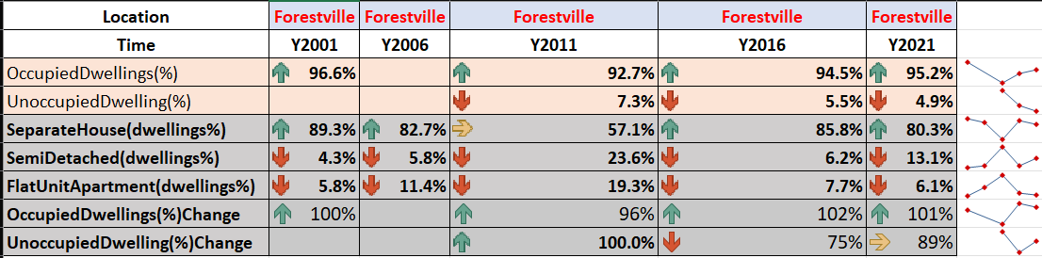

Figure

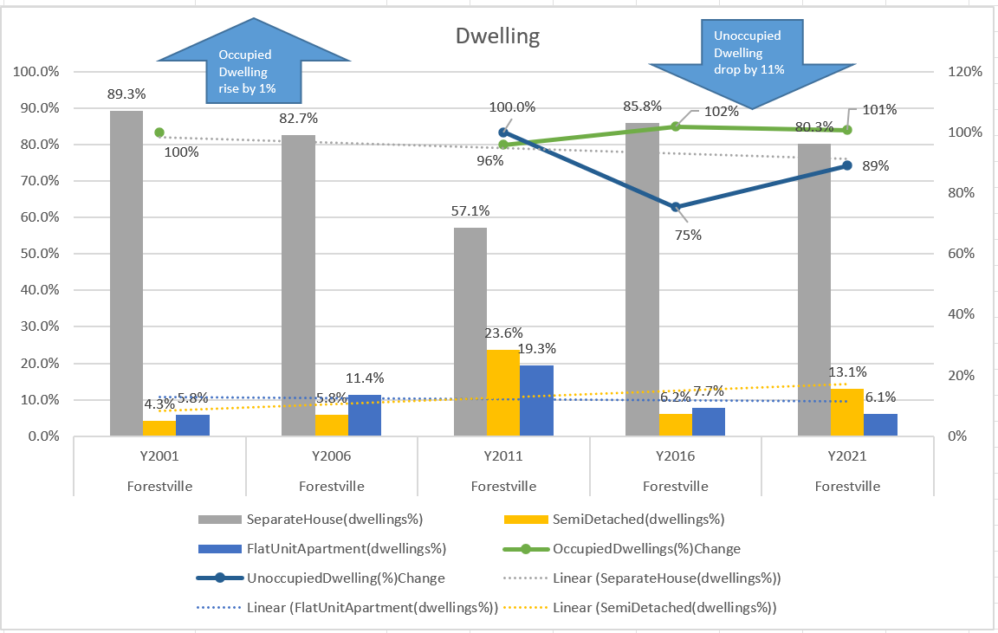

Figure

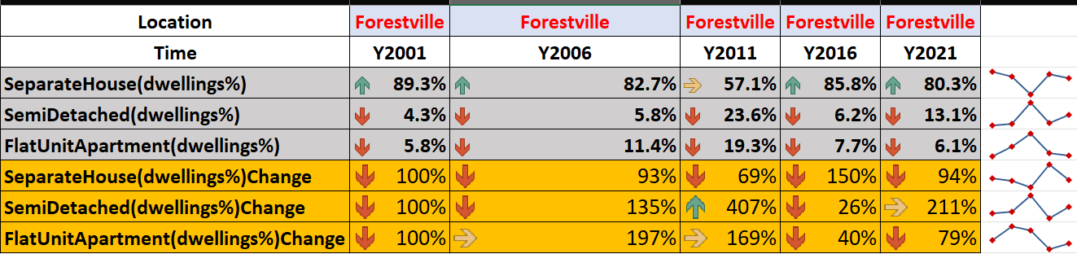

Figure

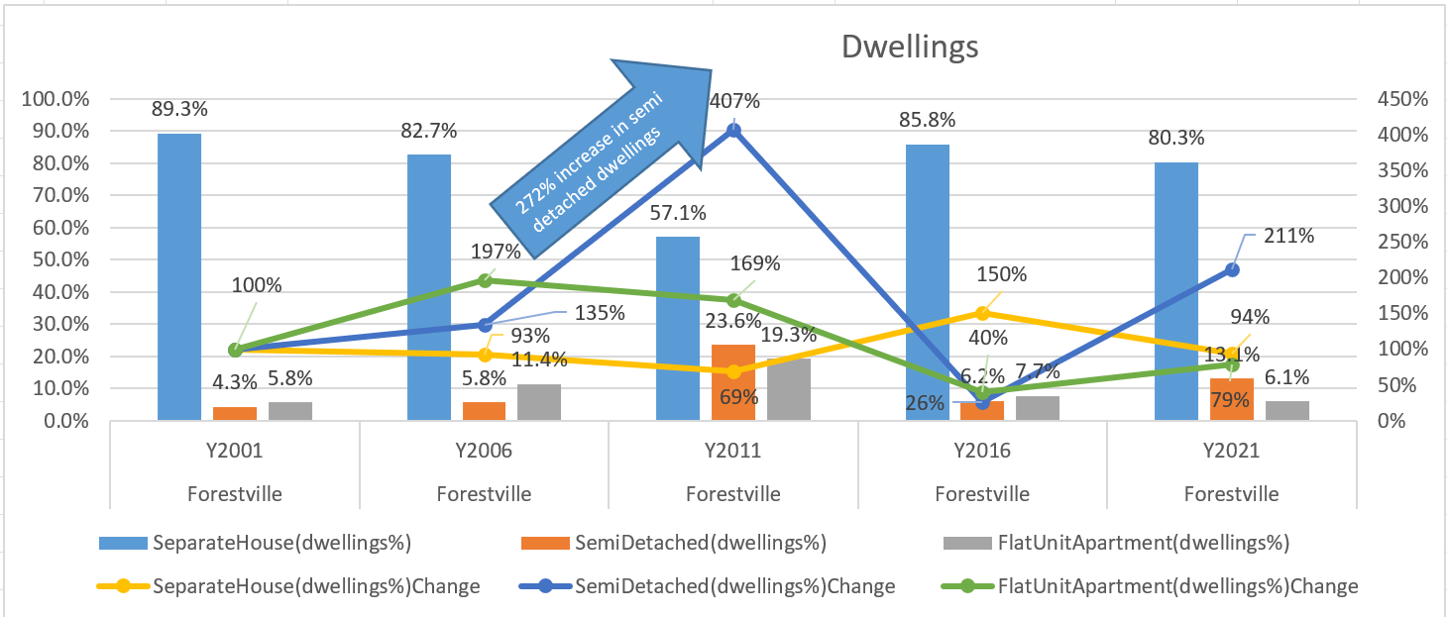

Figure

**Summary**

Over the years we can see that there has been a rise of occupied dwelling by 1% while the unoccupied dwellings has decreased over 11%. This suggests that supply on property has decreased over the periods. From figure 16, it is obvious that the most popular dwellings are separate houses, however it has dropped by 6% throughout the years. Furthermore, from the year 2006 to 2011 there was a surge in popularity of semi detached dwellings since it experienced a significant increase by over 200% followed by a massive downtrend of over 300% in the following time period. Similarly, flat unit apartments experienced a noticeable increase of a total 169% from the year 2001 to 2011 which also followed by a massive decrease of 129% in the next period.

**Visualization Technique**

Both figure 14 and figure 16 are combo charts, this is because combo charts are ideal when it comes to visualizing various variables in different formats on a single chart. In figure 14, column bars are used to visualize the values of different dwellings SeparateHouse dwelling, SemiDetached dwelling, and the FlatUnitApartments. Additionally the marked line chart is used to represent the occupiedDwelling and unoccupied dwelling’s movements. Similarly in figure 16, column bars are also used to visualize the same three variables in figure 14 however the line chart used in figure 16 is used to represent the movement of previous respective variables. Both figure 14 and 16 also added shapes in order to highlight noticeable movements or changes in the chart over the time periods followed by the additions of data labels and repositioning to improve readability and description of the chart.

# 9. Family:

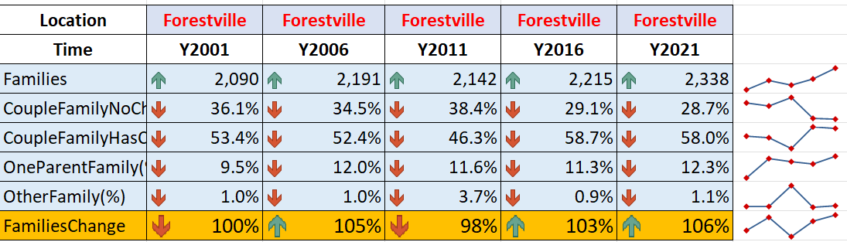

Figure

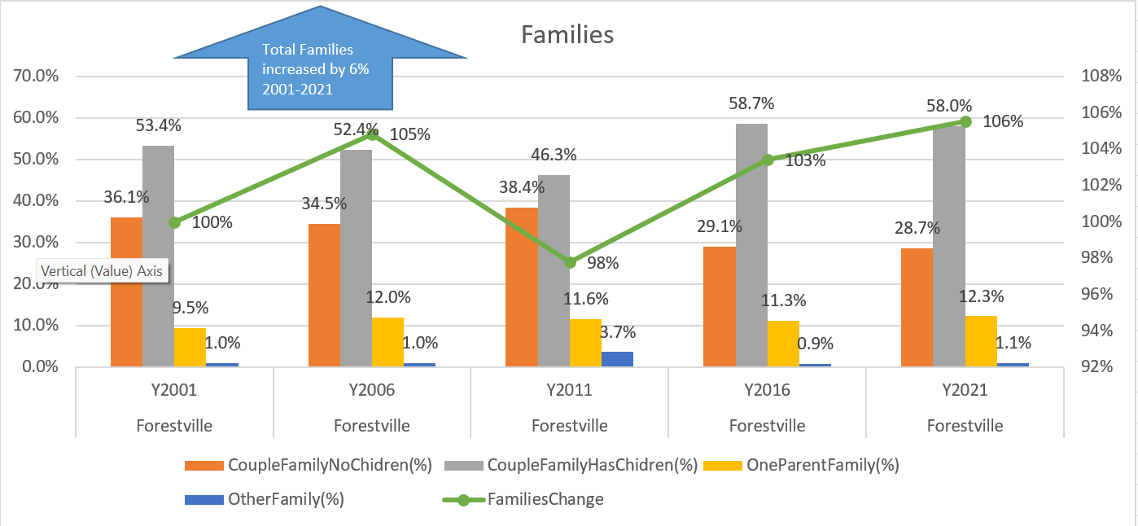

Figure

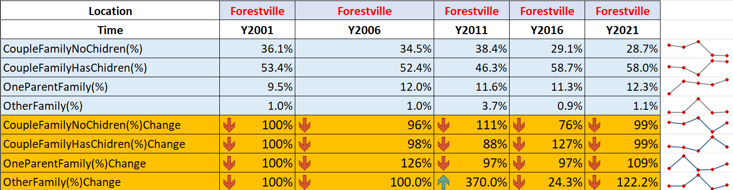

Figure

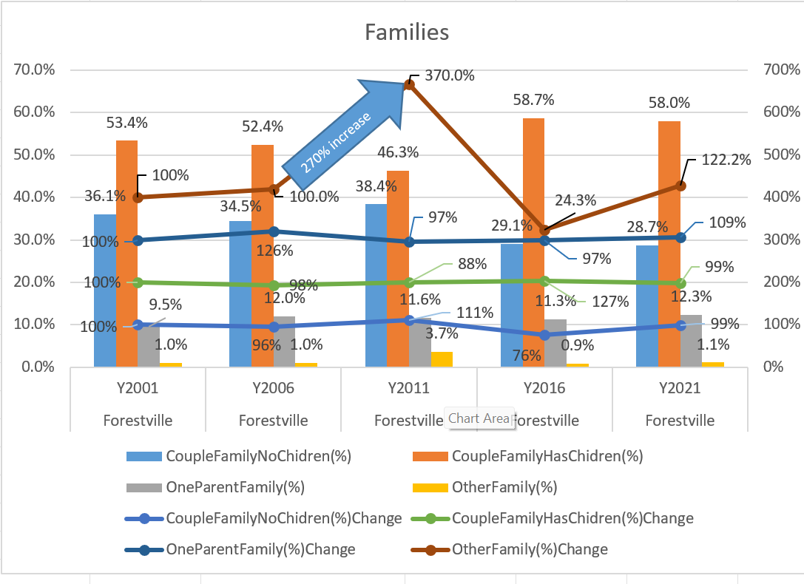

Figure

**Summary**

Families in Forestville has increased slightly overall by 6% throughout the years. Furthermore, from the year 2001 to 2021 the majority of the families were Couples who has children which experienced an increase of 3% over the periods. In addition, second majority of the families were couple families with no children which experienced an overall decrease of 8% through out the years. It is safe to assume that since there is only a slight increase of families with children, it is obvious that the population growth rate will only increase slightly as time went by. Although couples with no children has been decreasing, this suggests that couples with children will increase since both variables correlates with each other due to families having childrens as the year goes on.

**Visualization Technique**

Both figure 18 and 20 utilizes the combo chart. Combo charts are ideal when it comes to visualizing various variables in different formats on a single chart. In figure 18 the column bars represents the values of different families such as CoupleFamilieswithnochildren, couplefamilieswithchildren, Oneparentfamily, and otherfamily. Secondly, the line chart in figure 18 visualizes the movements and changes of total families in the region of Forestville. Similarly, figure 20 also utilizes the column bars to represent the values of different families while also using the line chart to visualize the movements and changes of each respective types of families through out the time periods. Furthermore, shapes are also used in order to highlight noticeable changes and movements in the chart followed by the assitions of data labels and repositioning to improve readability and description of the chart.

# Conclusion:

In the process of accomplishing this report there were a few obstacles faced, one of those were to reformat the axis range on the secondary axis on the combo chart. The issue was solved by clicking the right vertical axis and set the minimum and maximum of the range to the required amount, as a result the secondary axis can resized according to the data selected. There were also a few data node overlapping each other, in order to solve this different colours are set to each respective variable node in order to improve readability of the data nodes. Data labels are also added to every visualization to show the true values and changes of each variable in the chart. As prices of property rises and supply of unoccupied dwellings decreasing over the years accompanied with rise in demand, it is safe to assume that purchasing a property or a unit in Forestville could have the potential to yield profitable returns in the future due to the increasing population of the suburb and growing families. Throughout this assignment, combo chart proves to be advantageous in visualizing and measuring variables by allowing different visualization in a single chart.